%%%%%%%%%%%%%%%%%%%%%%%%%%%%%%%%%%%%%%%%%%%%%%%%%%%%%%%

**Example 3**

We apply the proposed scheme to solve aggregation-diffusion equation in an L-shaped area with



The initial data is

%%%%%%%%%%%%%%%%%%%%%%%%%%%%%%%%%%%%%%%%%%%%%%%%%%%%%%%

**Result**

1. **Free energy**

**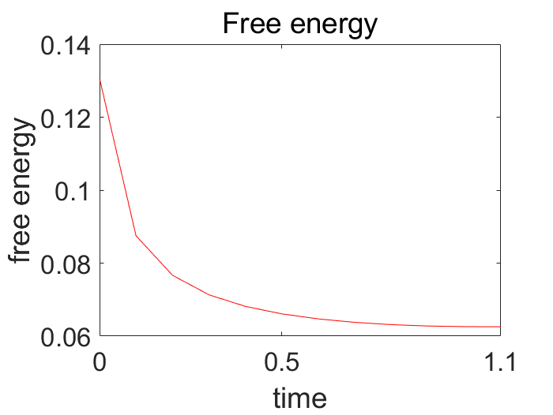**

Figure 1 Mesh size(1/24), time step(tau=1/40000)

1. **The mass conservation**

**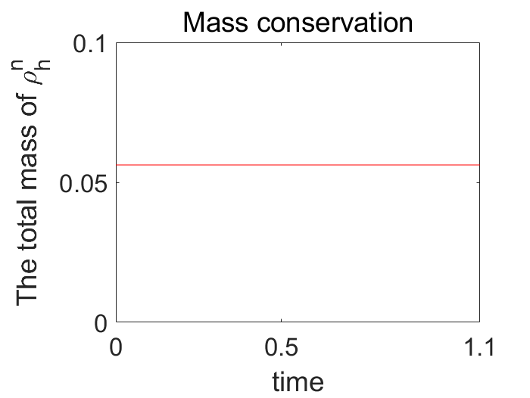**

Figure 2 Mesh size(1/24), time step(tau=1/40000)

1. **Numerical result**

|  |  |  |
| --- | --- | --- |
| rho_h_fill3_0  Figure 3 t = 0 | rho_h_fill3_1  Figure 4 t = 0.05 | rho_figure_at_t_0.5  Figure 5 t = 0.5 |
| rho_h_fill3_19  Figure 6 t = 0.95 | rho_h_fill3_20  Figure 7 t = 1.0 | rho_h_fill3_22  Figure 8 t = 1.1 |